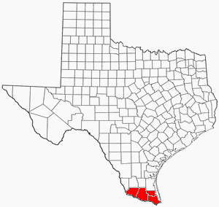
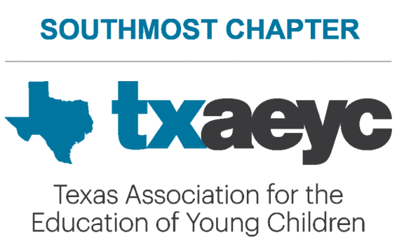

SPRING CONFERENCE- 4 HOURS CREDIT

WHEN: Saturday, April 20, 2024 8:30-1:00
TOPICS TO BE PRESENTED: Different sessions for Infant and Toddlers, Preschool and After-Schoolers, Directors, some sessions in Spanish-Topic: Guidance, Movement, Literacy and more!
EXTRA: Lots of door prizes, and vendors during breaks

LOCATION: Sabal Hall, UTRGV Brownsville Campus, (across from the parking lot)
2000 W. University Blvd, Brownsville, TX 78520

COST:
- Southmost Chapter members- $10 --You must pre-register
- Non-members-$25
- Students –$15 (include copy of college ID-email me the image if you are registering on-line)

Registration ENDS on, April 18, 2024
NO REGISTRATIONS ON DAY OF TRAINING
MASKS ARE ENCOURAGED. DUE TO INSURANCE, NO CHILDREN.

***REGISTER ON LINE with a credit card;
https://www.eventbrite.com/e/southmost-chapter-of-txaeyc-spring-conference-4-hours-credit-tickets-850935499987

--or--
***REGISTER BY MAIL WITH CHECK OR MONEY ORDER

Questions-956-346-2897 or mehollmann@sbcglobal.net


***Only fill this out if you are mailing a check/money order.*******
Name and phone number of each participant_________________________________________
***List names on back, please…

Name of Center/Organization______________________________________________________

Phone # of center ___________________ email of center ______________________________
Southmost Chapter
c/o Mary Elizabeth Hollmann
327 W. St. Charles St.
Brownsville, TX 78520

Make checks to- SOUTHMOST CHAPTER OF TXAEYC

Total amount of check/money order _____ Mail registrations to-

